Covid-19 Dashboard

**First Dashboard**

1] As per covid-19 India data I can easily identify total no. of cases, total no. of cured and death as per state and month wise.

2} In my first dashboard I represent total no. of confirmed cases in India.

3} In this dash board you can easily filler data as per state wise as well as Year, Quarterly and month wise.

4} In this Dashboard I used Clustered Column Chart to show the pivot chart of confirmed cases.

5} in this dashboard I use insert slicer to represent State.

Below are the data which is use in dashboard

|  |
| --- |
|  |
|  |

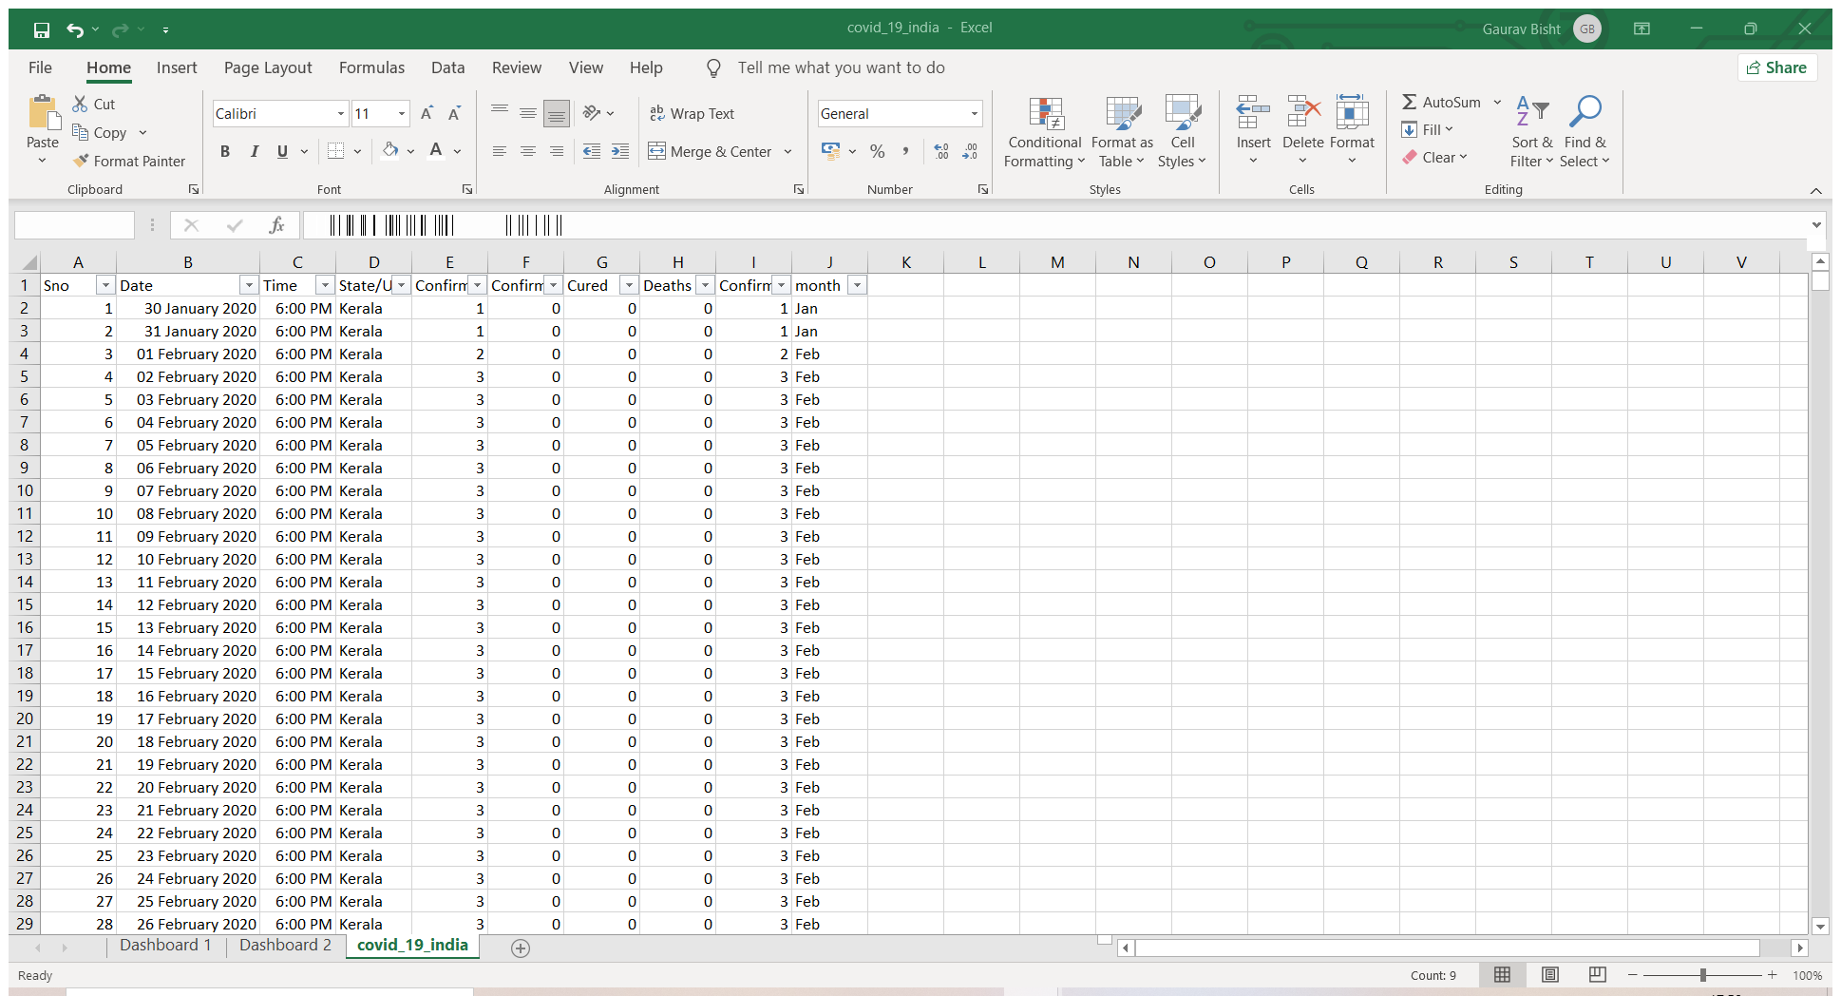

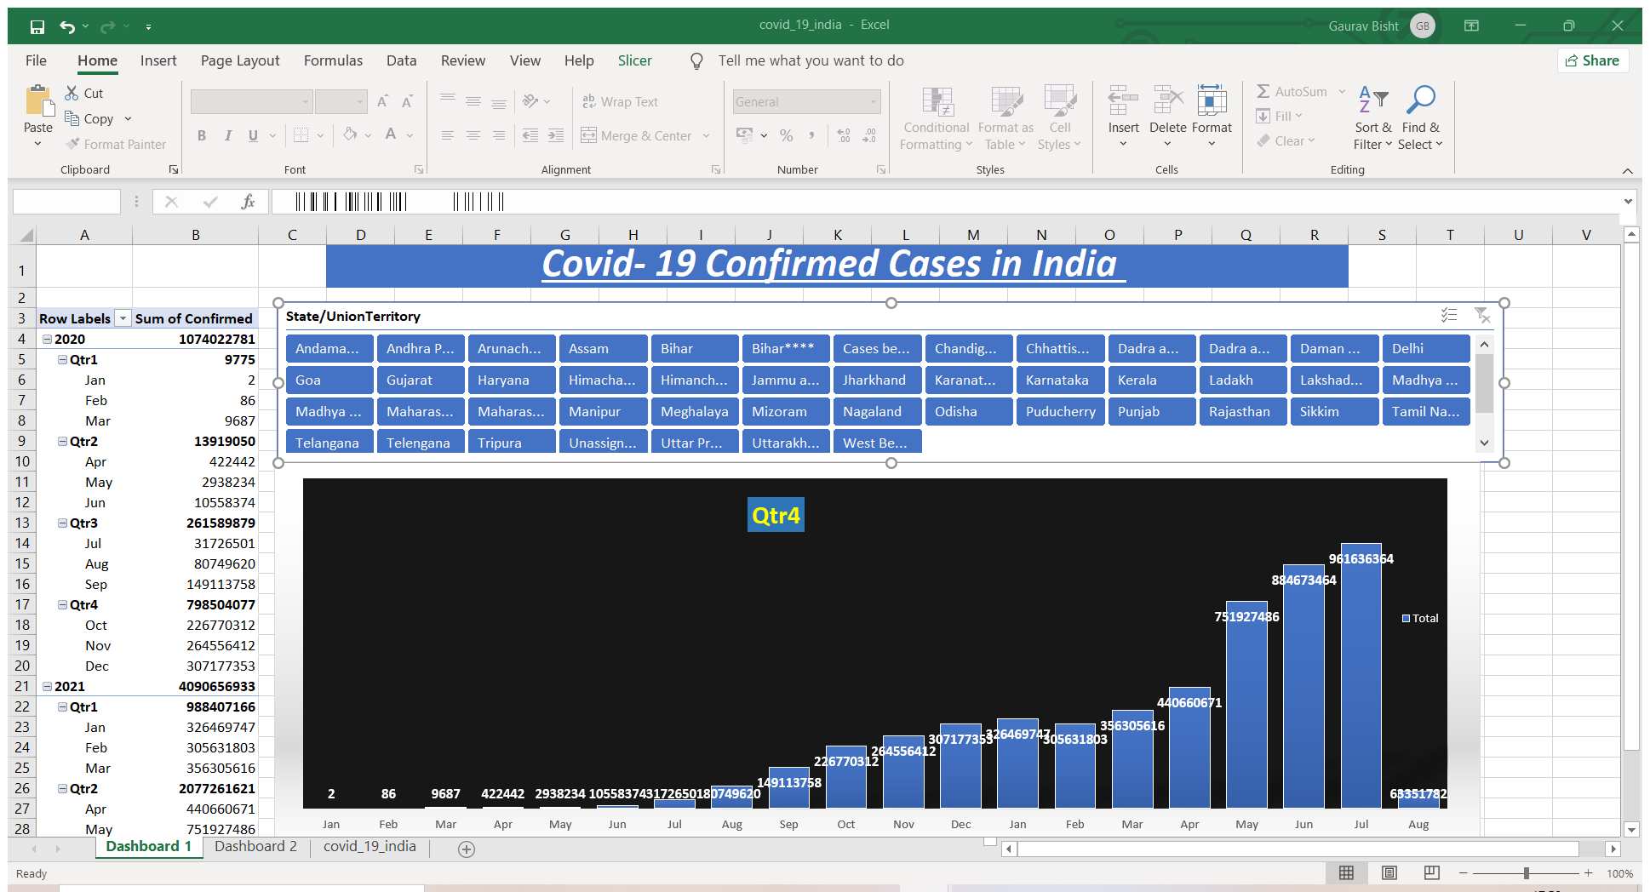

**Second Dashboard**

1] As per covid-19 India data I can easily identify total no. of cases, total no. of cured and death as per state and month wise.

2} In my second dashboard I represent Sum of Cured and Sum of Death

3} In this dash board you can easily filler data as per state wise as well as Year, Quarterly and month wise.

4} In this Dashboard I used Clustered Column Chart to show Sum of Death data and Line with Marker for sum of Cured so we can get a clear picture in pivot chart.

5} in this dashboard I use insert slicer to represent State.

Below are the data which is use in dashboard



